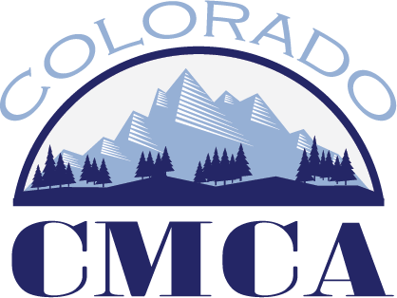

Marketing & Communication Committee
July 9, 2026 – 9 AM

- CML
  - Next year’s annual conference planning (Keystone)
  - Newsletters
- Social Media Small Group report out
- Institute
- Annual Conference:
- Clerk awards
- Canva items
  - Other committees projects

Upcoming Meetings:
August 11 at 10:00 AM
September 15 10:00 AM
Annual Conference: October 20-23 with Committee Transition meeting October 24th in Estes Park

Committee nominations will open August/September

