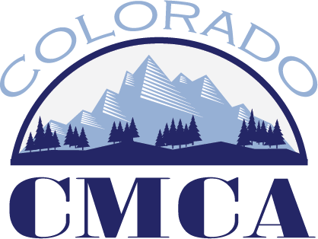

Education Committee Minutes
July 8, 2026 –2:00 p.m.

Microsoft Teams meeting
Join: https://teams.microsoft.com/meet/21467706032345?p=ixe2kFrBxWyY5mzS2M
Meeting ID: 214 677 060 323 45
Passcode: wk2LW789

- Subcommittee Reports
  - Professional Development Opportunities
    - Does the education committee want to allow fewer than 10 people to attend in person PDO’s?
      - It has been hard to get 10 people for PDO’s. 8 participants is still a good number. Recommendation to board: Lower minimum number of participants to 8.

      - Need to advertise PDO’s scholarships – if people cannot attend due to funds reach out to Kristen Teague – Are PDO’s to high? Are PDO’s drawing names for future PDO’s? Add marketing committee to advertise this as well.
    - What about virtual PDO’s?
      - After a discussion the committee decided to recommend lowering the minimum number of participants in virtual PDO’s to 8 and the maximum number of participants to 20. With a note that the teacher has to be comfortable with 20 but can lower the maximum number of participants. Recommendation to board: Lower minimum number of participants in a virtual PDO to 8 and maximum number to 20, per teacher approval.
    - How does the education committee feel about hybrid PDO’s?
      - No hybrid PDO’s
    - Cost of Virtual PDO’s?
      - Virtual PDO should be the same as an I person PDO. If we lowered virtual PDO’s everyone would want to attend those. Recommendation to Board: Lower the cost of virtual PDO’s by $20 for lunch expenses.
  - Institute
    - No update
  - Short Shots Committee
    - Another short shot is ready to go. It is on boards and commissions.
  - Athenian Dialogues / Masters Academy / Beyond MMC
    - No update
  - Educational Opportunity Review Work Group
    - The survey went out and it closes on the 24th. They are meeting at the end of the month and will start working on consistent curriculum.
- State Certification Conversations
  - Holding pattern right now as the board has been finalizing the Institute Directors contract. More to come over the next two to three months.
- Other

Next meeting is August 12th at 2pm.

PDO Work Group
Kristen Teague
Cindy Krieg
Bernadette Martinez

Institute Work Group
Tiffany O’Connell
Karen Frawley
Maili-lai Rael

Short Shots Work Group
Ben Florine
Rose Marie DeHerrera
Holly Martinez

Athenians / Masters Opportunities Work Group
Julie Barnett
Missy Carranco

Educational Opportunity Review Work Group
Holly Martinez
Ruben Santiago
Susan Ortiz
Haley Curtis

