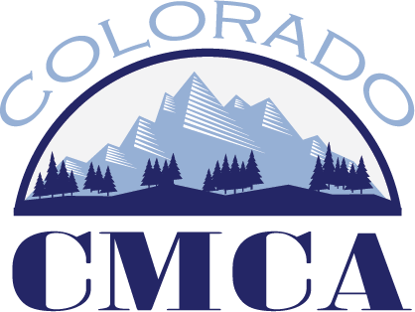

Education Committee Minutes
July 8, 2026 –2:00 p.m.

Microsoft Teams meeting
Join: https://teams.microsoft.com/meet/21467706032345?p=ixe2kFrBxWyY5mzS2M
Meeting ID: 214 677 060 323 45
Passcode: wk2LW789

- Subcommittee Reports
  - Professional Development Opportunities
    - Does the education committee want to allow fewer than 10 people to attend in person PDO’s? What about virtual PDO’s?
    - How does the education committee feel about hybrid PDO’s?
    - Cost of Virtual PDO’s?
  - Institute
  - Short Shots Committee
  - Athenian Dialogues / Masters Academy / Beyond MMC
  - Educational Opportunity Review Work Group
- State Certification Conversations
- Other

Next meeting is August 12th at 2pm.

PDO Work Group
Kristen Teague
Cindy Krieg
Bernadette Martinez

Institute Work Group
Tiffany O’Connell
Karen Frawley
Maili-lai Rael

Short Shots Work Group
Ben Florine
Rose Marie DeHerrera

Athenians / Masters Opportunities Work Group
Julie Barnett
Missy Carranco

Educational Opportunity Review Work Group
Holly Martinez
Ruben Santiago
Susan Ortiz
Haley Curtis

